Assigment 1 Report

OOP Design: I have 6 java classes namely

* GenericStatement (Class for the generic statemnets in the KB)
* KbaseArray(Class that used to populate the Array knowledge base and perform search and update operations)
* KBaseBST(Class that used to construct the BST knowledge base and perform updating manipulations and search)
* BNode(A class that defines the Binary Search Tree to be constructed)
* GenericStatementArrayInterface(The user interface for the array implementation)
* GenericStatementBSTInterface(The class for the implementation of the binary search tree )

The GenericStattemnet class is used to store the statement from the line in the file as an object. It holds the key, fact and confidence score for easy access and as the building block of both the array and binary search tree.

The array implementation of the knowledge base uses the KbaseArray class to extract the kb from the file and has other features like searching the newly created array…etc.

The BST implementation uses the BNode class to construct the BST node of type GenericStatement. It is used in the KbaseBST class to construct the knowledge base. The KbaseBST has the core methods of getting the lines into the BST and searching algorithms.

The project has two interface classes each using their respective data structure Knowledge base constructors.

Test Cases

1. Loading Knowledge base into the array

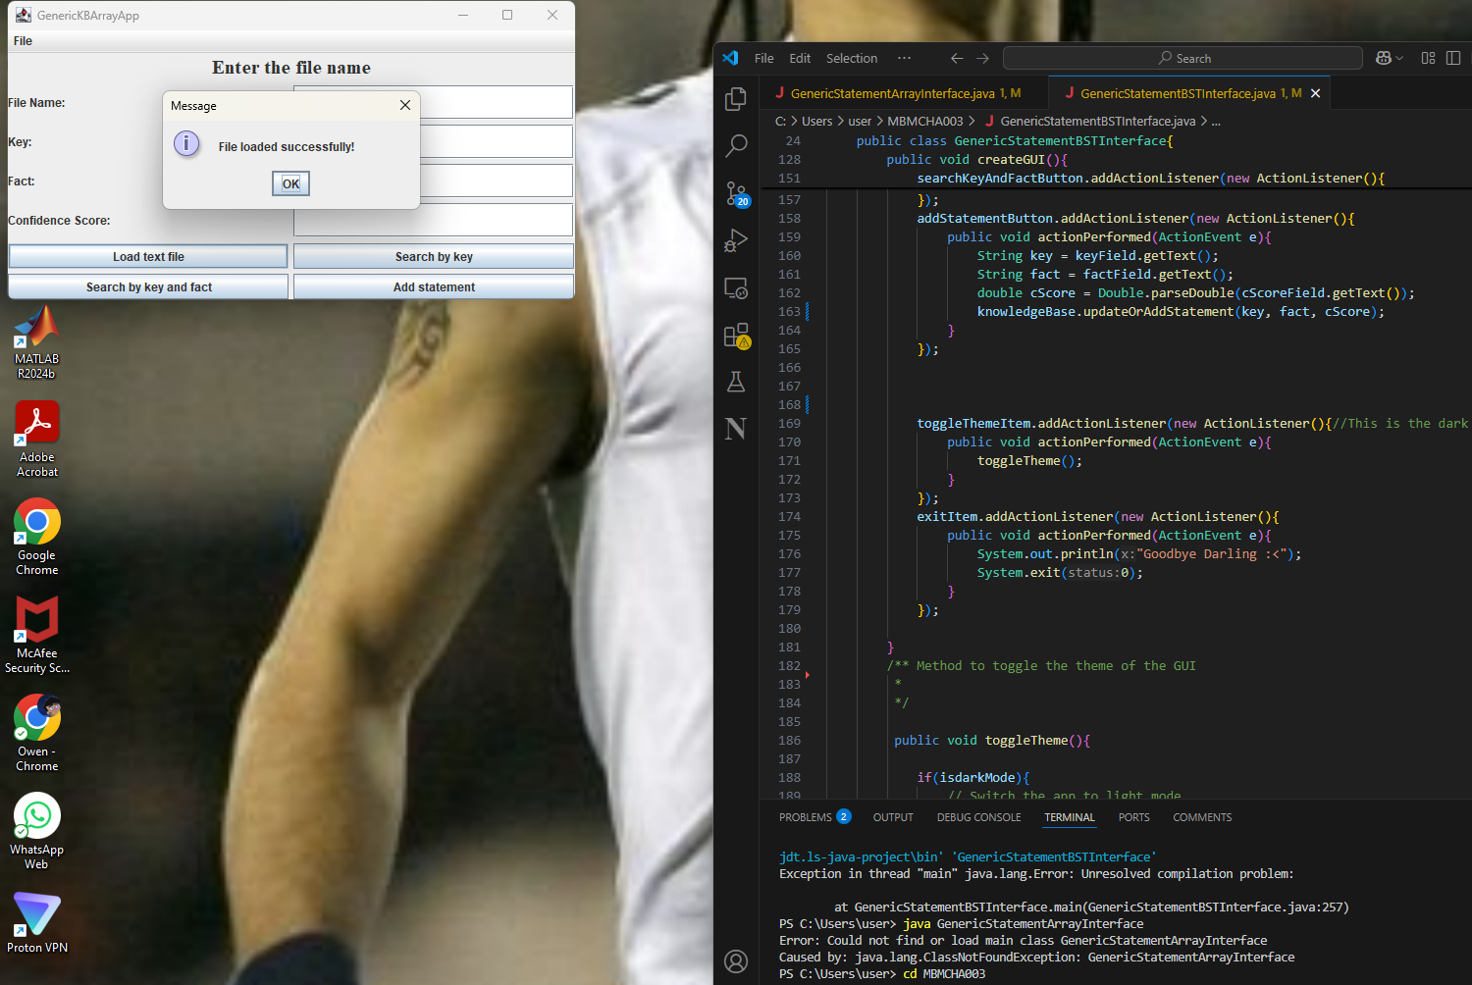

1. Searching a term from the array knowledgebase



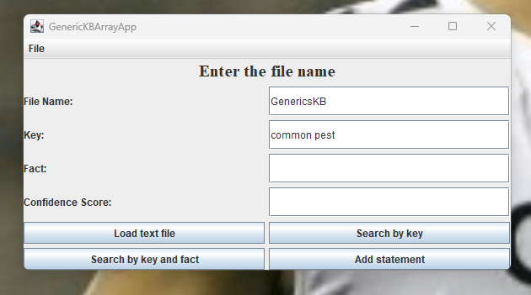

1. Searching the term and fact in a knowledge base

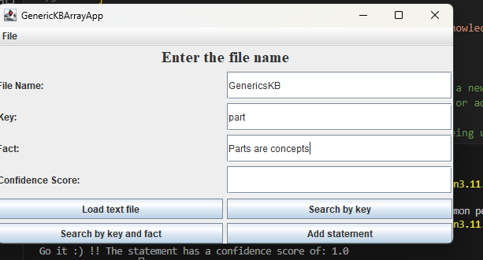

1. Trying to update a term in the knowledge base

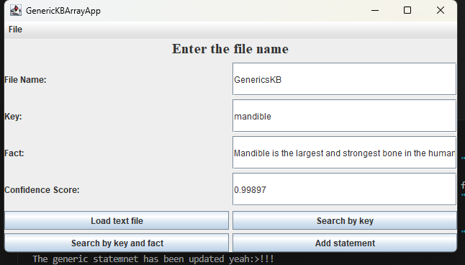

Testing the BST implementation

1.Loading the knowledge base into the BST

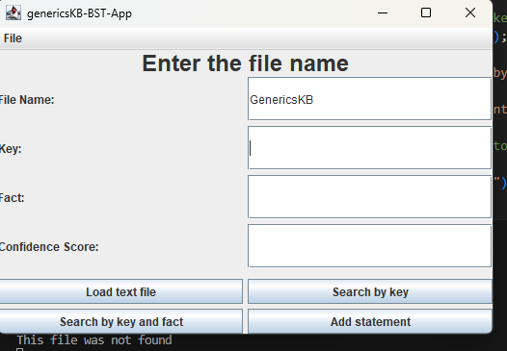

2.Searching for a key in the knowledge base

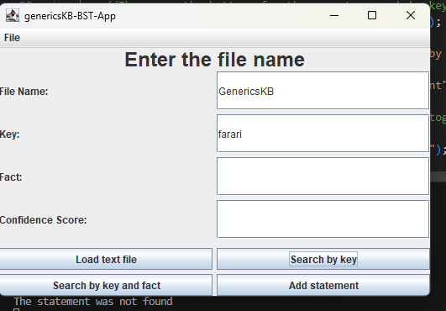

3.Search for a term and its fact in the bst kb

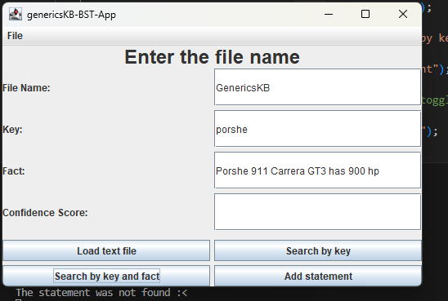

1. Try to update the knowledge

